**Overview**

In this exercise you will perform the initial server migrations to Azure that are possible using Azure Migrate. As Server 2003 is not capable of a migration using Azure Migrate we will review this at a later stage.

This exercise is spilt into two areas, migration and post migration.

**Migration steps**

Review Azure Migrate options to confirm all are connect for each VM that will be migrated

* Correct Subnet
* Static IP on VM
* Correct VM sizing
* Managed Disk enabled

**Post-Migration tasks to be completed on each VM**

1. Install Azure Dependency agent on the migrated VMs
   1. <https://docs.microsoft.com/en-us/azure/virtual-machines/extensions/agent-windows>
   2. <https://docs.microsoft.com/en-us/azure/virtual-machines/extensions/agent-linux>
2. CMD:- “ipconfig /registerdns”
3. Check VM disks, ensure they are standard HDD
4. Assign correct Application Security Group
5. Assign Correct Network Security Group
6. Ensure VM has Static IP
7. Boot Diagnostics setup
8. Add VM to Azure Log analytics account
9. Malware/AV extension installed (Microsoft Antimalware) with exclusion list as below – full scan on Saturday at 2am
10. Configure Log analytics for newly created TF Log Analytics Resource

Web Exclusion List

|  |  |  |
| --- | --- | --- |
| **Excluded files & location** | **Excluded File Types** | **Excluded Processes** |
| C:\NTDS *pagefile.sys %windir%\Security\Database %windir%\SoftwareDistribution\DataStore\* | .mpg | Taskmgr.exe |

SQL Exclusion List

|  |  |  |
| --- | --- | --- |
| **Excluded files & location** | **Excluded File Types** | **Excluded Processes** |
| C:\NTDS *pagefile.sys %windir%\Security\Database %windir%\SoftwareDistribution\DataStore\* <SQL Install locations> | .mpg .bak .ldf .MDF .NDF  .SQL .SQLAudit .TRC .TRN | Taskmgr.exe |

Application, ensure the valid is still appearing and available from Hyper-V host. Screenshot as below Is the example web page.

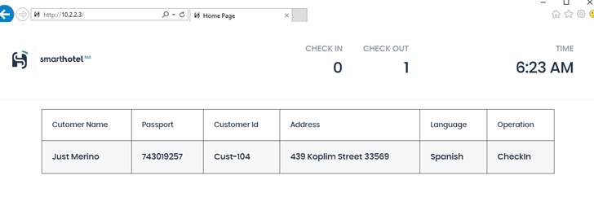

**Exercise targets**

1. Ensure all available VMs are migrated
2. Post-migration tasks complete on each VM
3. Migrated application is accessible and displaying correctly from Hyper-V Host